**PENTAHO Data Integration Tool Downloading Steps**

**STEP 1**. **Download Pentaho Data Integration Software**

You can download the files from this link.

The page will look something like this:

You can download the files from this link.

The page will look something like this:

You can download the files from this link.

The page will look something like this:

* You can download the files from this link(<https://www.hitachivantara.com/en-us/products/lumada-dataops/data-integration-analytics/pentaho-community-edition.html>)
* The page will look something like this.

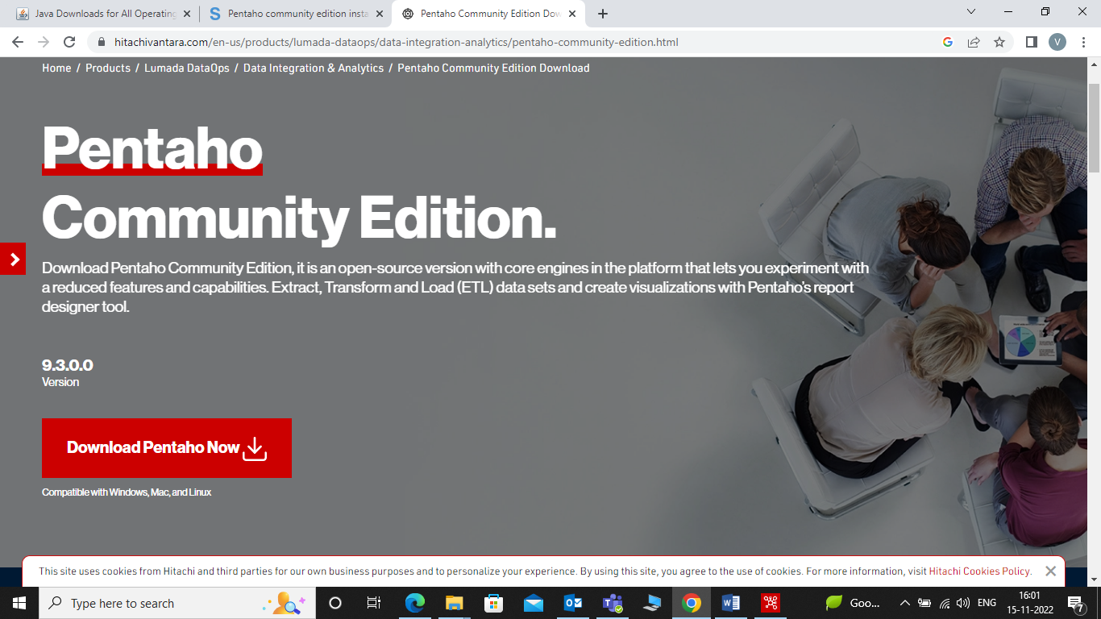

3

Introduction

In this tutorial, we’ll be going over the steps to install Pentaho Data Integration, part of Hitachi’s Lumada portfolio, on

your Microsoft Windows computer and to start the app.

Prerequisites

●● An Oracle account (for Java software).

●● Windows 8 or 10 operating system.

●● Permission to edit environment variables on your computer.

●● Permission to download and install Java.

Full supported computing environments can be found here.

Step 1. Download Pentaho Data Integration Software

The first thing we need is the Pentaho Data Integration software that we’ll be working with.

You can download the files from this link.

The page will look something like this:

Press the “Download” button and to start a zip file download on your computer.

Once the zip file is done downloading, extract the files into a folder you can work with.

Your folder should look something like this

* Press on Download Pentaho Now Button.
* Once the Zip file is downloaded, extract the files into the folder you can work with.

4

Step 2. Install the Java Dependencies, if Required

**STEP 2**: **Install the Java Dependencies, if Required**

* To run Pentaho Data Integration Tool, Java Runtime Environment and Java Development Kit are required.
* If the java dependency required files are not installed, Download JDK and JRE files from the below links.
* JDK link(https://www.oracle.com/in/java/technologies/downloads/).

JRE link(https://www.java.com/en/download/manual.jsp).

3

Introduction

In this tutorial, we’ll be going over the steps to install Pentaho Data Integration, part of Hitachi’s Lumada portfolio, on

your Microsoft Windows computer and to start the app.

Prerequisites

●● An Oracle account (for Java software).

●● Windows 8 or 10 operating system.

●● Permission to edit environment variables on your computer.

●● Permission to download and install Java.

Full supported computing environments can be found here.

Step 1. Download Pentaho Data Integration Software

The first thing we need is the Pentaho Data Integration software that we’ll be working with.

You can download the files from this link.

The page will look something like this:

Press the “Download” button and to start a zip file download on your computer.

Once the zip file is done downloading, extract the files into a folder you can work with.

Your folder should look something like this

**STEP 3: Set Up the Environment Variables**

* There are three Environment Variables that you need to set up.
* Type in “Environment Variables” in the Windows Search Bar like this

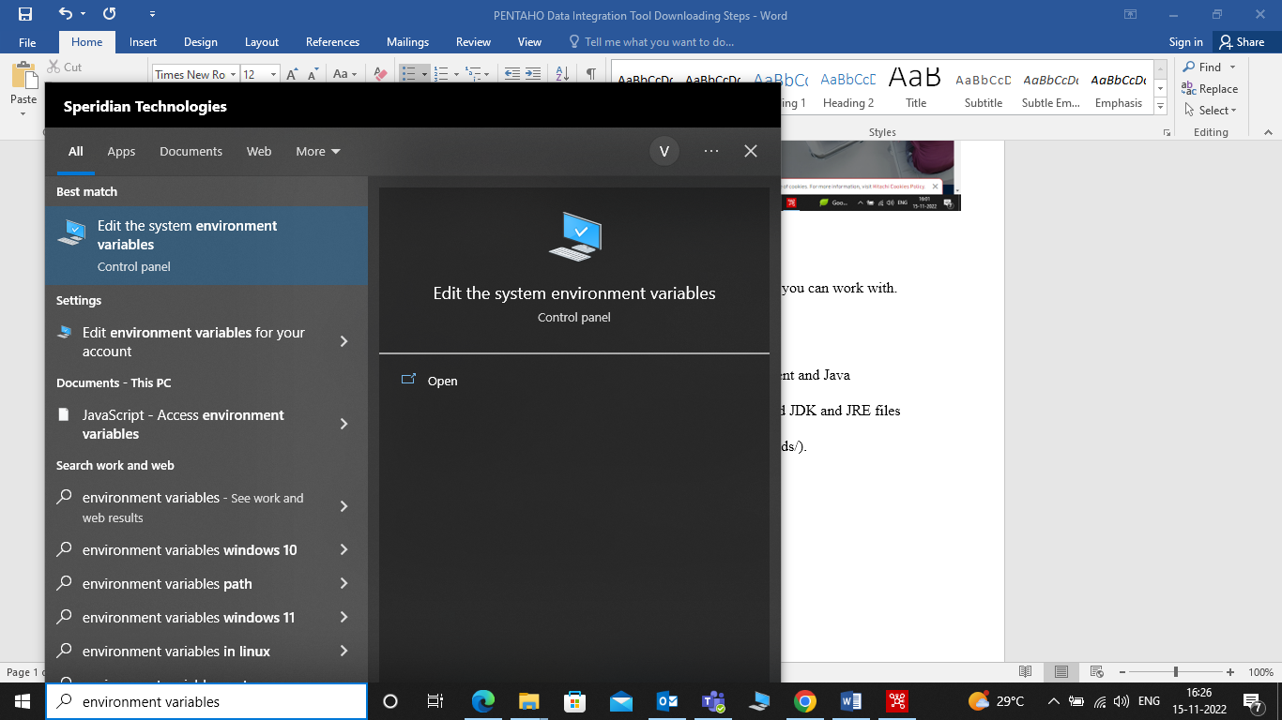

* Click on Edit the system environment variables” option.
* System Properties window will open, Click on “Environment Variables” button at the bottom.

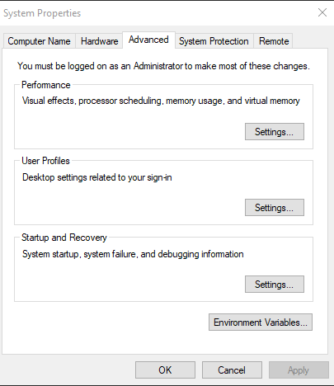

* A window will be opened which looks like this.

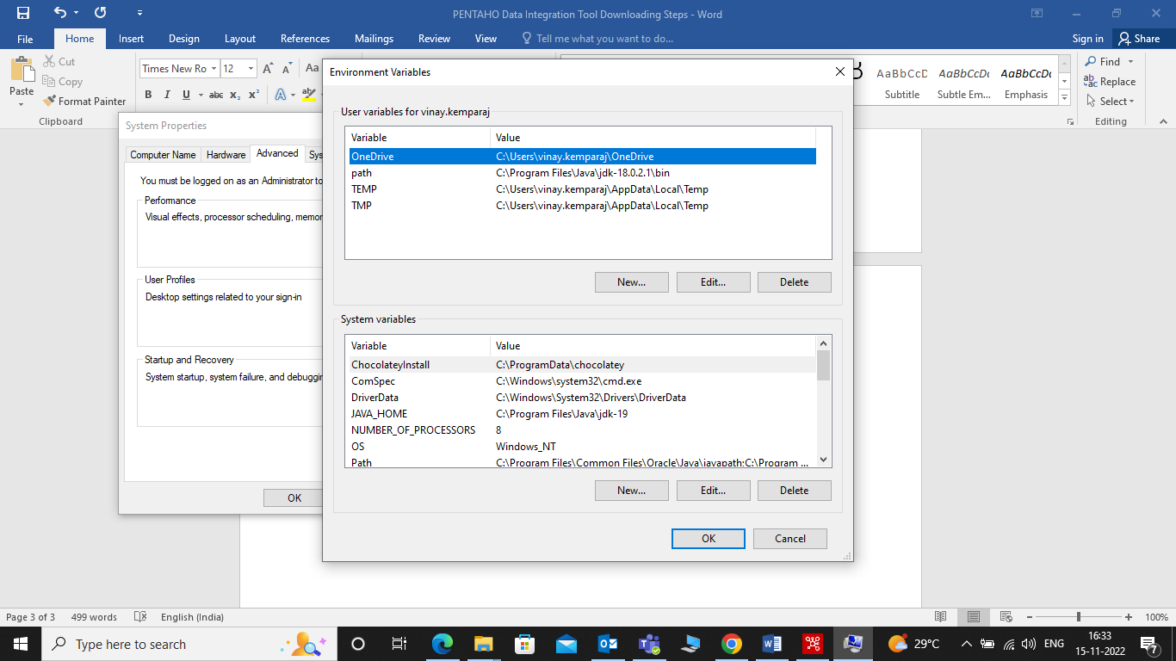

* We need to add three new System variables.
* Click the “New…” button under “System variables” and enter the following:

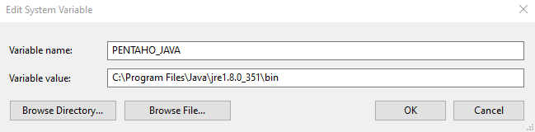

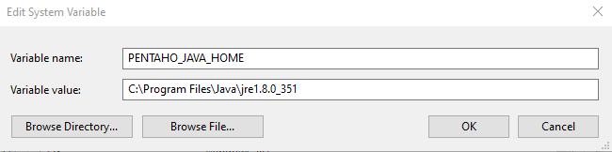

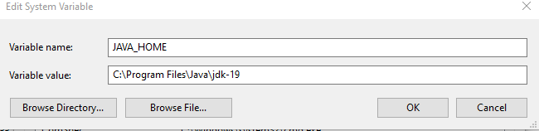

**STEP 4**: **Open the Pentaho Data Integration App**

* Now that Java is Installed and Environment variables are set we can run the Pentaho Data Integration App.
* The Data Integration Folder that we downloaded looks like this.

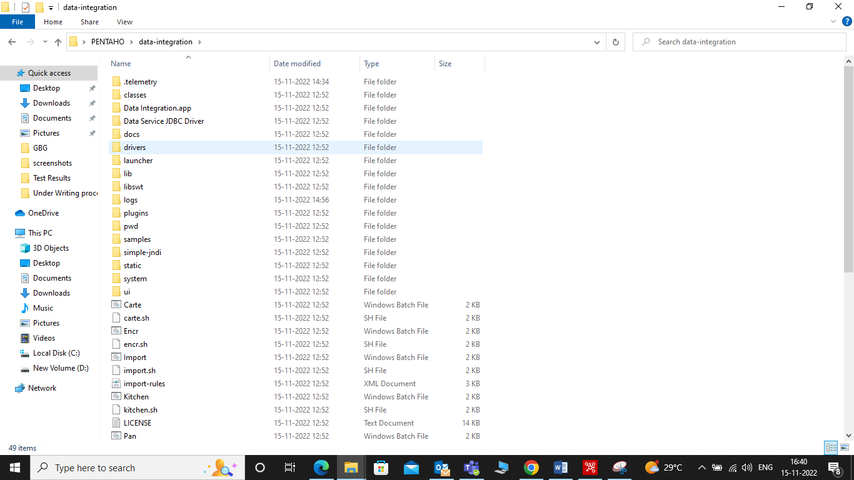

* The file that runs the app is “Spoon”.
* Double click on this file to open Pentaho data integration tool, as shown below.

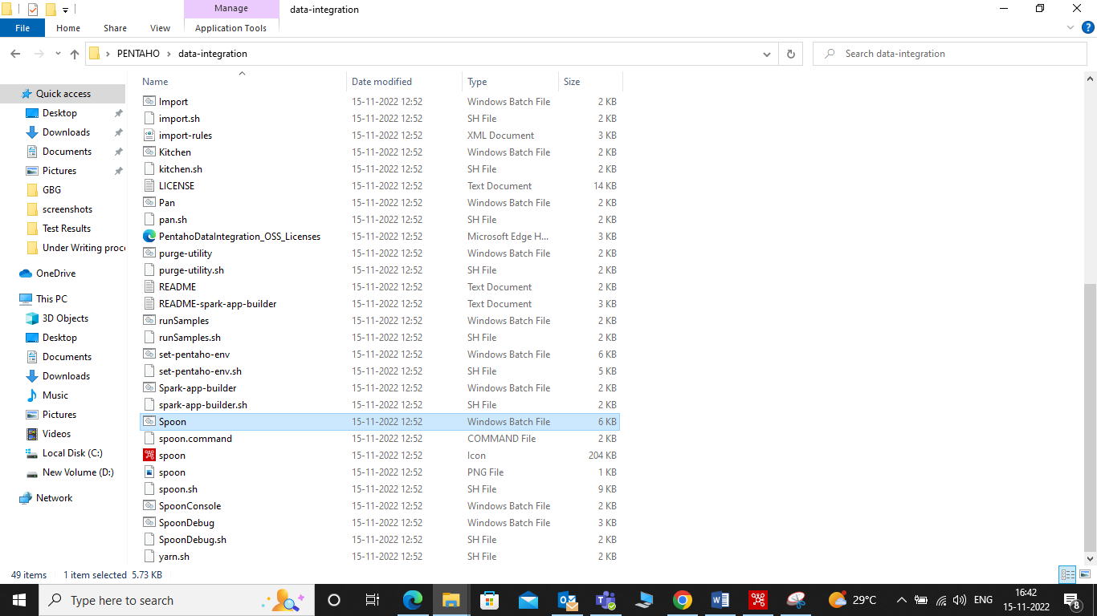

* Pentaho Data Integration Tool will be opened as shown below

